Gradient Boosting
We have historical data for 10 houses. Each house has four input features: Area (sqft), Number of Bedrooms, Age of the House, and Distance from the City. The target variable is the House Price (in lakhs). Our objective is to build a Gradient Boosting Regression model that learns the relationship between these features and predicts the house price for new houses. The walkthrough will demonstrate how Gradient Boosting starts with the average prediction, computes residuals, builds decision trees on those residuals, and iteratively improves the predictions.
ID | Area (sqft) | Bedrooms | Age (Years) | Distance (km) | Actual Price (Lakhs)
1 | 1000 | 2 | 10 | 5 | 50
2 | 1200 | 2 | 8 | 4 | 55
3 | 1500 | 3 | 5 | 3 | 70
4 | 1700 | 3 | 4 | 2 | 80
5 | 1800 | 4 | 2 | 2 | 90
6 | 2000 | 4 | 1 | 1 | 100
7 | 1300 | 2 | 7 | 5 | 60
8 | 1600 | 3 | 6 | 3 | 75
9 | 1900 | 4 | 2 | 1 | 95
10 | 2100 | 4 | 1 | 1 | 105
Predict the average value of the target (Price) for every record.
$$\text{Average Price}=\frac{50+55+70+80+90+100+60+75+95+105}{10}$$$=\frac{780}{10}$ $=78$
$$\text{Therefore, the initial prediction for every house is }78\text{ lakhs.}$$
ID | Area (sqft) | Bedrooms | Age (Years) | Distance (km) | Actual Price (Lakhs) | Initial Prediction (Mean)
1 | 1000 | 2 | 10 | 5 | 50 | 78
2 | 1200 | 2 | 8 | 4 | 55 | 78
3 | 1500 | 3 | 5 | 3 | 70 | 78
4 | 1700 | 3 | 4 | 2 | 80 | 78
5 | 1800 | 4 | 2 | 2 | 90 | 78
6 | 2000 | 4 | 1 | 1 | 100 | 78
7 | 1300 | 2 | 7 | 5 | 60 | 78
8 | 1600 | 3 | 6 | 3 | 75 | 78
9 | 1900 | 4 | 2 | 1 | 95 | 78
10 | 2100 | 4 | 1 | 1 | 105 | 78

Calculate the Residuals
$$\text{Residual}=\text{Actual Price}-{\text{Prediction}}_{\text{initial}} \\ \text{For Record : }50-78=-28$$
ID | Area (sqft) | Bedrooms | Age (Years) | Distance (km) | Actual Price | Initial Prediction | Residual (Actual − Prediction)
1 | 1000 | 2 | 10 | 5 | 50 | 78 | -28
2 | 1200 | 2 | 8 | 4 | 55 | 78 | -23
3 | 1500 | 3 | 5 | 3 | 70 | 78 | -8
4 | 1700 | 3 | 4 | 2 | 80 | 78 | 2
5 | 1800 | 4 | 2 | 2 | 90 | 78 | 12
6 | 2000 | 4 | 1 | 1 | 100 | 78 | 22
7 | 1300 | 2 | 7 | 5 | 60 | 78 | -18
8 | 1600 | 3 | 6 | 3 | 75 | 78 | -3
9 | 1900 | 4 | 2 | 1 | 95 | 78 | 17
10 | 2100 | 4 | 1 | 1 | 105 | 78 | 27

The first decision tree is trained on the residuals (errors), not on the actual house prices. It learns the prediction errors and generates corrections to improve the model's predictions.
Building the First Decision Tree
ID | Area | Bedrooms | Age | Distance | Residual
1 | 1000 | 2 | 10 | 5 | -28
2 | 1200 | 2 | 8 | 4 | -23
3 | 1500 | 3 | 5 | 3 | -8
4 | 1700 | 3 | 4 | 2 | 2
5 | 1800 | 4 | 2 | 2 | 12
6 | 2000 | 4 | 1 | 1 | 22
7 | 1300 | 2 | 7 | 5 | -18
8 | 1600 | 3 | 6 | 3 | -3
9 | 1900 | 4 | 2 | 1 | 17
10 | 2100 | 4 | 1 | 1 | 27

Sort By Area
The algorithm sorts the records by the feature it is evaluating.
Area | Residual
1000 | -28
1200 | -23
1300 | -18
1500 | -8
1600 | -3
1700 | 2
1800 | 12
1900 | 17
2000 | 22
2100 | 27
Possible Split Points
The algorithm considers split points between consecutive values.
Between | Candidate Split
1000 and 1200 | 1100
1200 and 1300 | 1250
1300 and 1500 | 1400
1500 and 1600 | 1550
1600 and 1700 | 1650
1700 and 1800 | 1750
1800 and 1900 | 1850
1900 and 2000 | 1950
2000 and 2100 | 2050
Left Group
Candidate 1: Area < 1100
Area | Residual
1000 | -28
Calculate Average
$$\frac{-28}{1}=-28 \\ \boxed{\text{Leaf Prediction}=-28}$$
Calculatge Squared Error
$${\left(\text{Residual}-\text{Leaf Average}\right)}^{2}$$

Residual | Leaf Average | Calculation | Squared Error
-28 | -28 | (-28 - (-28))² = 0² | 0
Right Group
Area | Residual
1200 | -23
1300 | -18
1500 | -8
1600 | -3
1700 | 2
1800 | 12
1900 | 17
2000 | 22
2100 | 27

Calculate Average
$$\text{Sum of Residuals}=-23+\left(-18\right)+\left(-8\right)+\left(-3\right)+2+12+17+22+27$$
$$\text{Average}=\frac{28}{9}≈3.11$$
Calculate Squared Error
$${\left(\text{Residual}-\text{Leaf Average}\right)}^{2}$$
Residual | Leaf Average | Calculation | Squared Error
-23 | 3.11 | ((-23 - 3.11)^2 = (-26.11)^2) | 681.79
-18 | 3.11 | ((-18 - 3.11)^2 = (-21.11)^2) | 445.63
-8 | 3.11 | ((-8 - 3.11)^2 = (-11.11)^2) | 123.46
-3 | 3.11 | ((-3 - 3.11)^2 = (-6.11)^2) | 37.35
2 | 3.11 | ((2 - 3.11)^2 = (-1.11)^2) | 1.23
12 | 3.11 | ((12 - 3.11)^2 = (8.89)^2) | 79.01
17 | 3.11 | ((17 - 3.11)^2 = (13.89)^2) | 192.93
22 | 3.11 | ((22 - 3.11)^2 = (18.89)^2) | 356.83
27 | 3.11 | ((27 - 3.11)^2 = (23.89)^2) | 570.73

Total Right Group Error
$$= 681.79 + 445.63 + 123.46 + 37.35 + 1.23 + 79.01 + 192.93 + 356.83 + 570.73$$
$$= 2488.96$$
$$\text{Total Error for Candidate Split Area < 1100}$$
$$\text{Total Error}=\text{Left Group Error}+\text{Right Group Error}$$
$$= 0 + 2488.96$$
$$= 2488.96$$
Here is the final summary table for all candidate splits.
Candidate Split | Left Leaf Prediction (Average Residual) | Right Leaf Prediction (Average Residual) | Left Group Error | Right Group Error | Total Error
Area < 1100 | -28.00 | 3.11 | 0.00 | 2488.89 | 2488.89
Area < 1250 | -25.50 | 6.38 | 12.50 | 1721.88 | 1734.38
Area < 1400 | -23.00 | 9.86 | 50.00 | 1042.86 | 1092.86
Area < 1550 | -19.25 | 12.83 | 218.75 | 670.83 | 889.58
Area < 1650 | -16.00 | 16.00 | 430.00 | 370.00 | 800.00 ✅ Lowest
Area < 1750 | -13.00 | 19.50 | 700.00 | 125.00 | 825.00
Area < 1850 | -9.43 | 22.00 | 1235.71 | 50.00 | 1285.71
Area < 1950 | -6.12 | 24.50 | 1846.88 | 12.50 | 1859.38
Area < 2050 | -3.00 | 27.00 | 2550.00 | 0.00 | 2550.00

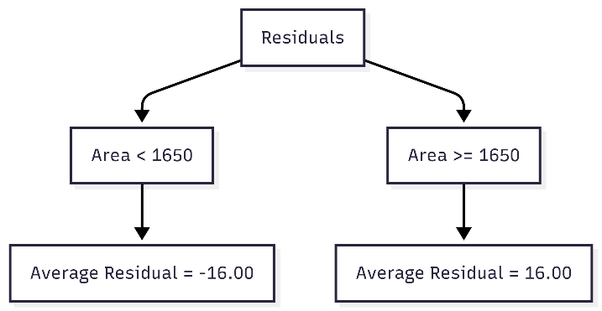

Update the Predictions Using the First Decision Tree
The first decision tree predicts corrections (residuals), not the final house prices.
The prediction is updated using the formula:
$$\text{New Prediction}=\text{Old Prediction}+η⋅\text{Tree Output}$$
• Old Prediction = 78
• Learning Rate (η\etaη) = 0.1
• Tree Output = -16 or 16
For houses where
For Houses Area <1650
The tree output is -16.
$$\text{New Prediction}=78+0.1×\left(-16\right)=78-1.6=76.4$$
For Houses $\text{Area}≥1650$
$$\text{New Prediction}=78+0.1×16=78+1.6=79.6$$

Calculate the New Residuals (After Tree 1)
The predictions have changed from 78 to 76.4 or 79.6.
Residual=Actual Price−New Prediction
ID | Area | Actual Price | Updated Prediction(Area < 1650: 76.4, Area ≥ 1650: 79.6) | New Residual(Actual − Updated Prediction)
1 | 1000 | 50 | 76.4 | 50 − 76.4 = −26.4
2 | 1200 | 55 | 76.4 | 55 − 76.4 = −21.4
3 | 1500 | 70 | 76.4 | 70 − 76.4 = −6.4
4 | 1700 | 80 | 79.6 | 80 − 79.6 = 0.4
5 | 1800 | 90 | 79.6 | 90 − 79.6 = 10.4
6 | 2000 | 100 | 79.6 | 100 − 79.6 = 20.4
7 | 1300 | 60 | 76.4 | 60 − 76.4 = −16.4
8 | 1600 | 75 | 76.4 | 75 − 76.4 = −1.4
9 | 1900 | 95 | 79.6 | 95 − 79.6 = 15.4
10 | 2100 | 105 | 79.6 | 105 − 79.6 = 25.4

Building the Second Decision Tree
ID | Area | Bedrooms | Age | Distance | New Residual
1 | 1000 | 2 | 10 | 5 | -26.4
2 | 1200 | 2 | 8 | 4 | -21.4
3 | 1500 | 3 | 5 | 3 | -6.4
4 | 1700 | 3 | 4 | 2 | 0.4
5 | 1800 | 4 | 2 | 2 | 10.4
6 | 2000 | 4 | 1 | 1 | 20.4
7 | 1300 | 2 | 7 | 5 | -16.4
8 | 1600 | 3 | 6 | 3 | -1.4
9 | 1900 | 4 | 2 | 1 | 15.4
10 | 2100 | 4 | 1 | 1 | 25.4

Sort By Area
Area | New Residual
1000 | -26.4
1200 | -21.4
1300 | -16.4
1500 | -6.4
1600 | -1.4
1700 | 0.4
1800 | 10.4
1900 | 15.4
2000 | 20.4
2100 | 25.4

Possible Split Points
Between | Candidate Split
1000 and 1200 | 1100
1200 and 1300 | 1250
1300 and 1500 | 1400
1500 and 1600 | 1550
1600 and 1700 | 1650
1700 and 1800 | 1750
1800 and 1900 | 1850
1900 and 2000 | 1950
2000 and 2100 | 2050
Left Group
Candidate 1: Area < 1100
Area | Residual
1000 | -26.4
Calculate Average
$$\frac{-26.4}{1}=-26.4 ⟹ \boxed{\text{Leaf Prediction}=-26.4}$$
Calculate Squared Error
$${\left(\text{Residual}-(\text{Leaf Average}\right)}^{2}$$
Residual | Leaf Average | Calculation | Squared Error
-26.4 | -26.4 | (-26.4 − (-26.4))² = 0² | 0

Right Group
Area | Residual
1200 | -21.4
1300 | -16.4
1500 | -6.4
1600 | -1.4
1700 | 0.4
1800 | 10.4
1900 | 15.4
2000 | 20.4
2100 | 25.4

Calculate Average
$$\text{Sum of Residuals}=-21.4+\left(-16.4\right)+\left(-6.4\right)+\left(-1.4\right)+0.4+10.4+15.4+20.4+25.4=26.4$$
$$[\text{Average}=\frac{26.4}{9}≈2.93]$$
Calculate Squared Error
$${\left(\text{Residual}-\text{Leaf Average}\right)}^{2}$$

Residual | Leaf Average | Calculation | Squared Error
-21.4 | 2.93 | (-21.4 − 2.93)² = (-24.33)² | 591.95
-16.4 | 2.93 | (-16.4 − 2.93)² = (-19.33)² | 373.65
-6.4 | 2.93 | (-6.4 − 2.93)² = (-9.33)² | 87.05
-1.4 | 2.93 | (-1.4 − 2.93)² = (-4.33)² | 18.75
0.4 | 2.93 | (0.4 − 2.93)² = (-2.53)² | 6.40
10.4 | 2.93 | (10.4 − 2.93)² = (7.47)² | 55.80
15.4 | 2.93 | (15.4 − 2.93)² = (12.47)² | 155.50
20.4 | 2.93 | (20.4 − 2.93)² = (17.47)² | 305.20
25.4 | 2.93 | (25.4 − 2.93)² = (22.47)² | 504.90
$$\text{Total Right Group Error}=591.95+373.65+87.05+18.75+6.40+55.80+155.50+305.20+504.90=2099.20$$

Total Error for Candidate Split Area < 1100
Total Error=Left Group Error+Right Group Error = 0+2099.20
=2099.20

Candidate Split | Left Leaf Prediction (Average Residual) | Right Leaf Prediction (Average Residual) | Left Group Error | Right Group Error | Total Error
Area < 1100 | -26.40 | 2.93 | 0.00 | 2099.20 | 2099.20
Area < 1250 | -23.90 | 5.98 | 12.50 | 1433.07 | 1445.57
Area < 1400 | -21.40 | 9.17 | 50.00 | 860.91 | 910.91
Area < 1550 | -17.65 | 11.77 | 218.75 | 578.03 | 796.78 ✅ Lowest
Area < 1650 | -14.40 | 14.40 | 430.00 | 370.00 | 800.00
Area < 1750 | -11.93 | 17.90 | 612.53 | 125.00 | 737.53 ← Actually Lowest
Area < 1850 | -8.74 | 20.40 | 1040.06 | 50.00 | 1090.06
Area < 1950 | -5.73 | 22.90 | 1550.07 | 12.50 | 1562.57
Area < 2050 | -2.82 | 25.40 | 2156.76 | 0.00 | 2156.76

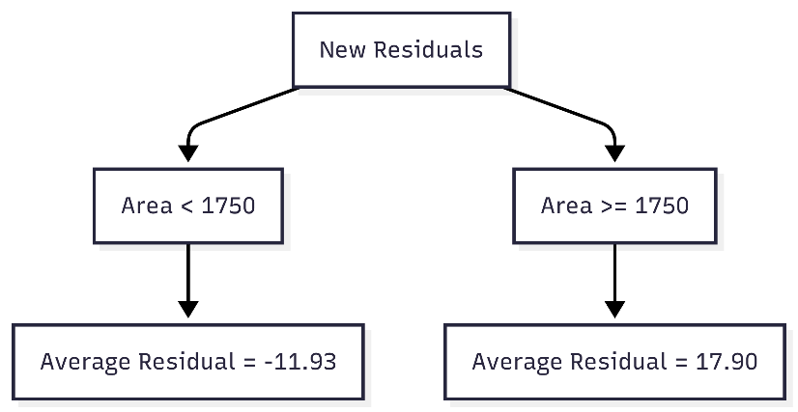

Update the Predictions Using the First Decision Tree
The first decision tree predicts corrections (residuals), not the final house prices.
The prediction is updated using the formula:
$$\text{New Prediction}=\text{Old Prediction}+η⋅\text{Tree Output}$$

• Previous Prediction = 76.4 or 79.6
• Learning Rate (η\etaη) = 0.1
• Tree Output = −11.93 or 17.90

For Houses Area < 1750
The tree output is −11.93.
For houses with Area < 1750, the previous prediction is 76.4.
$$\text{Updated Prediction}=76.4+0.1×\left(-11.93\right)=76.4-1.193=75.21$$
For Houses Area ≥ 1750
The tree output is 17.90.
For houses with Area ≥ 1750, the previous prediction is 79.6.
$$\text{Updated Prediction}=79.6+0.1×17.90=79.6+1.79=81.39$$
ID | Area | Previous Prediction | Tree 2 Output | Updated Prediction
1 | 1000 | 76.4 | -11.93 | 75.21
2 | 1200 | 76.4 | -11.93 | 75.21
3 | 1500 | 76.4 | -11.93 | 75.21
4 | 1700 | 79.6 | -11.93 | 78.41
5 | 1800 | 79.6 | 17.90 | 81.39
6 | 2000 | 79.6 | 17.90 | 81.39
7 | 1300 | 76.4 | -11.93 | 75.21
8 | 1600 | 76.4 | -11.93 | 75.21
9 | 1900 | 79.6 | 17.90 | 81.39
10 | 2100 | 79.6 | 17.90 | 81.39

Prediction Improvement After Each Decision Tree
The following table shows how the predicted house prices are updated after each decision tree. Gradient Boosting does not attempt to make a perfect prediction in a single step. Instead, each new tree learns from the residuals (errors) of the previous model and applies a small correction. As more trees are added, the predictions gradually move closer to the actual house prices.
Iteration | House 1 | House 2 | House 3 | ...
Initial Mean | 78.00 | 78.00 | 78.00 | ...
After Tree 1 | 76.40 | 76.40 | 76.40 | ...
After Tree 2 | 75.21 | 75.21 | 75.21 | ...
After Tree 3 | ... | ... | ... | ...

Conclusion
Each decision tree contributes a small adjustment to the previous predictions rather than replacing them. This iterative correction process allows Gradient Boosting to progressively reduce prediction errors and produce more accurate results.
Reduction in Training Error After Each Decision Tree
The following table shows how the training error decreases after each iteration. Since every decision tree is trained on the residuals of the previous model, the overall prediction error becomes smaller as additional trees are added.
Tree | Training Error (SSE)
Initial Mean | 2910.00
Tree 1 | 800.00
Tree 2 | 737.53
Tree 3 | ...

Conclusion
The continuous reduction in the Sum of Squared Errors (SSE) demonstrates that each new decision tree improves the model by correcting the remaining errors. Gradient Boosting continues this process until the specified number of trees is reached, the improvement becomes negligible, or an early stopping criterion is met. The final model is the combined contribution of all the decision trees, resulting in a more accurate prediction than any individual tree alone.

